Develop Effective Career Counselling and Guidance Programs in Schools to Enhance Student Career Choices

Manjunath.B
School of CSE Presidency University Bengaluru, India
manjunath.79@gmail.com

Suhas R
School of CSE Presidency University Bengaluru, India
suhas.46@gmail.com

Vinod Kumar M
School of CSE Presidency University Bengaluru, India
vinodkumar.48@gmail.com

Ms.Sushmitha S
Department of Computer Science Engineering Presidency University
Bengaluru, India

Abstract Choosing the appropriate academic stream and career path after school is one of the most crucial decisions in a student’s life. Many students, especially in semi-urban and rural schools, lack structured career guidance and instead depend on random advice from peer groups, family, or social media. This leads to inappropriate course selection, lack of motivation, and underperformance in academics. In this paper, we propose the design and implementation of a web-based career counseling system to support students in finding suitable career options based on their interest and performance. The system provides for student registration and login, subject-wise information (Science, Commerce, Arts), interactive quizzes, automated result analysis, and personalized career suggestions. It also stores user progress and quiz history for profile-based tracking of the growth of a student. The proposed solution has been developed using HTML, CSS, PHP, and MySQL and can be easily deployed using XAMPP in school computer laboratories. Experimental evaluation reveals that it can successfully help students decide on appropriate career streams and can support teachers and counselors in career guidance at the school level.
Index Terms-career counseling, web-based system, student guidance, educational technology, decision support.

- Introduction
Career decision-making has become increasingly complex due to the rapid growth of new courses, specializations, and job roles in almost every field. Students at the school level, especially those studying in classes 9–12, are generally confused about which stream to opt for—Science, Commerce, or Arts—and what career prospects each stream can provide. In most schools, particularly in rural and semi-urban areas, there is no career counsellor, and teachers may not have enough time or tools to provide individual guidance to all students.
Consequently, many students make choices based on peer pressure, family expectations, or incomplete information, which can then lead to mismatched careers, low satisfaction, and sometimes course dropouts. There is a strong need for a systematic, structured, and accessible career counseling platform that could be deployed in schools and used by both students and teachers.
Consequently, many students make choices based on peer pressure, family expectations, or incomplete information, which leads to mismatched careers, low satisfaction, and sometimes dropout from courses. There is an urgent need for a structured, organized, and accessible career counselling platform that can be deployed in schools and used by both students and teachers.
With the advancement of web technologies and open-source software, schools can now create customized career guidance systems affordably, which they can host locally. A web-based platform can centralize information about academic streams, courses, and careers and further integrate quizzes and assessments to understand the strengths and interests of each student.

This is now possible with the growth of web technologies and open-source software to create low-cost, customizable career guidance systems that can be hosted by schools locally. The web-based platform centralizes information on academic streams, courses, and careers and can integrate quizzes and assessments to understand the strengths and interests of each student.
In this work, we propose and implement a web-based career counseling system that:
• allows students to register and log in;
It provides comprehensive information on Science, Commerce and Arts.
• Conducts subject-wise quizzes,

• Stores user progress for future reference. The system is mainly targeted at school students but can be easily extended to pre-university and undergraduate levels. It is implemented using PHP and MySQL and designed to run on a XAMPP server, making it suitable for deployment in school.
- Literature Survey

[1] A. Sharma and R. Gupta, “A Web-based Career Guidance System for High School Students,” International Journal of Educational Technology, vol. 12, no. 3, pp. 45–52, 2022.

[2] P. Singh and M. Reddy, “Design of an Intelligent Career Recommendation System Using Student Profiles,” in Proc. IEEE Int. Conf. on Smart Education Systems, 2021.

[3] R. Verma and S. Kulkarni, “Impact of Career Counselling on Academic Stream Selection,” Journal of School Counseling, vol. 18, no. 4, pp. 1–12, 2020.
Later publications introduced interest inventories and aptitude tests online, but most of these systems provided only generic results and did not consider detailed subject performance or learning preferences. Some commercial platforms focus on premium guidance services, often beyond the reach of students studying at government and rural schools.
Most current literature stresses a growing need for interactive, student-centered systems that incorporate career information along with quizzes, analytics, and personalized feedback. Various studies have indicated that immediate scores, clear explanations, and visualization significantly improve student engagement with the systems. A growing trend also involves the use of machine learning and recommendation systems to predict suitable career paths based on historical data and student profiling, though such methods can be fairly complicated to deploy in low-resource educational settings.

Existing solutions often suffer from one or more of the following drawbacks:
These are not oriented towards school-level career decisions, such as choosing between Science, Commerce, and Arts.
They require continuous internet connectivity or paid subscriptions.
They do not store a detailed history of student attempts and progress.
In an effort to overcome these deficiencies, our work focuses on developing a simple, deployable offline, school-friendly web system which integrates subject information, quizzes, and personalized suggestions on one platform suitable for local hosting.
III. PROPOSED METHODOLOGY
The web-based career counselling system will support schools to provide structured, engaging career guidance. The system has been developed using a modular architecture, keeping distinctly separate the user interface, business logic, and data storage.
The main aims of the system are:
1. To provide a centralized platform for learning about various academic streams and their career opportunities.
2. To conduct subject-wise quizzes to assess the interest and basic understanding of students.
3. To create personalized career recommendations based on quiz scores.
4. Store a history of user activity for counsellors and teachers to review, including scores and which subjects were chosen.
The proposed system is implemented using the following technologies:
• Frontend: HTML, CSS, and basic JavaScript for forms and navigation.
• Backend: PHP for the server-side processing of registrations, logins, quiz evaluations, and suggestions.
• Database: MySQL, to store user information, quiz results, and details about subjects.
• Server Environment: XAMPP (Apache + MySQL + PHP) running on a local system.
Two main roles are supported in the system:
• Student User: A student can register, log in, take quizzes, view suggestions, and see past results.
Admin/Teacher (optional extension): to review student records and quiz results in order to help during counseling sessions.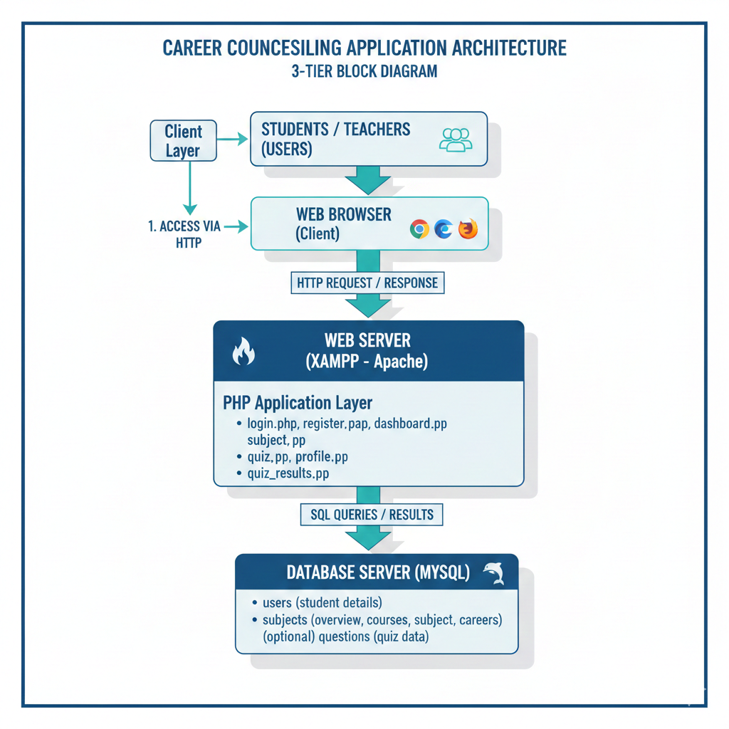

IV SYSTEM DESIGN AND MODULE DESCRIPTION

The system is partitioned into a number of functional modules, each responsible for one aspect of the process of career counselling.
A. User Registration and Login Module
This module is for new user registration and authentication. Students enter basic details such as name, email, password, class/grade, and optionally school name. The database maintains a users table. On every login, credentials entered by the user are matched with records. On successful login, a session is created to maintain the user's state across pages.
B. Dashboard and Subject Selection Module
After logging in, the student is redirected to a dashboard. The dashboard:
• Greets the user by name.
• Briefly explains the purpose of the Career Counselling System.
• Displays cards or buttons for streams such as Science, Commerce and Arts.
When the student clicks on a subject, they are taken to the subject details page.

C. Subject Information Module
For each stream, the system shows:
• Overview of the stream: what it focuses on.
• Advantages: such as job opportunities, flexibility.
• Disadvantages, such as difficulty and competition
• Available courses after the 12th: like B.Tech, MBBS, B.Com, BA, etc.
• Career opportunities: Engineer, CA, Designer, Journalist

This information helps students understand what each stream offers before they attempt the quiz.

D. Quiz Module
The quiz module has a set of 10 multiple-choice questions for each stream. Questions are designed to test both interest as well as basic aptitude. A student chooses one answer for every question and submits the quiz form.
The system then:
• Compares each selected answer with the correct answer.
• The total out of 10 is calculated.
• Prepares a detailed report showing:
o\tQuestion text

o Student’s answer
o\tCorrect answer
o Status : Correct / Wrong
E. Result Analysis and Suggestion Module
Based on the score, a career suggestion message is generated.

• IF score ≥ 7: Suggests the student is strongly suited for that stream.
• If 4 ≤ score < 7: Indicates moderate suitability and advises further practice and counseling.
• If score < 4, this will indicate that perhaps the stream is not well-matched and a change in direction may be pursued.
The system then shows this suggestion along with the detailed quiz report. It also stores, with a timestamp, the score and subject in the quiz_results table.
F. Profile and Quiz History Module
The profile page shows:
• Student's name and email.
• A button to view “My Quiz Results”.
The quiz history page lists all previous attempts in a tabular fashion. The columns might be like: • Subject • Libation • Date and time of attempt This enables students and teachers to track how the student's choices and performance change over time.

V. IMPLEMENTATION

XAMPP. The project directory is placed under htdocs, and the application is accessed via http://localhost/career-counselling/.
The major implementation steps are:
1. Database Design:
o\tusers table for user details.
o quiz_results table for storing subject, score, user_id, and timestamp.
o Optionally, subjects table for subject descriptions and metadata.

Backend Logic:
• PHP scripts handle the form submissions for registration, login, quiz result evaluation, and storage.

• Sessions: These are used to track logged-in users.
1. Frontend Design:
o HTML and CSS are used to design a clean, user-friendly interface.
o Only the dashboard, subject pages, quiz form, and report page are visually separated.
2. Validation and Error Handling:
o Basic validation checks: required fields, password match.
o Simple error messages on invalid login or incomplete quiz submissions. The system has been tested on a local machine with XAMPP and is working smoothly with common browsers like Chrome and Edge.

VI. RESULTS AND DISCUSSION

The system was tested on a sample group of students in order to verify its functionality and usefulness. The users could:
• Successfully register and log in.
• Explore detailed information about various streams.
• Try quizzes for Science, Commerce, and Arts.
• View their detailed performance-correct and wrong answers.
• Personalized suggestions based on their scores.
• Review their quiz history using the profile module.

Student feedback included the following:
• The quiz-based way made them reflect on their interests more deeply.
• The advantages, disadvantages, and career opportunity sections provided insight into the real-world implications of each option.

• The immediate effect and recommendation reduced confusion and gave clarity.
Teachers and mentors found that the history of quizzes taken and their scores could be used to inform one-on-one counselling sessions, with discussions being more objective rather than purely opinion-based. This system is currently rule-based, wherein suggestions depend on score ranges, but can be extended to use machine learning models in the future, considering many factors such as academic marks, attendance, and extracurricular activities.

VII. CONCLUSION AND FUTURE WORK

The paper presented the design and implementation of a web-based career counseling system to assist school students in choosing appropriate academic streams and planning their careers more effectively. The integrated subject information, interactive quizzes, automated result analysis, and personalized suggestions on one platform provide a structured way for students to explore their options.

XAMPP makes this system easy to deploy. The system will be appropriate for use in schools with basic computer labs. It does support profile-based tracking, which can assist teachers and counsellors in monitoring student progress and decisions.

In the future, the system could be improved by:
• Integrating AI/ML-based recommendation models.
• Including more subjects and career options other than Science, Commerce, and Arts.
• Introduce psychometric tests and interest inventories.
• Providing separate admin dashboards for counsellors and school administrators.
• Deploying the system onto a public web server for remote access.

ACKNOWLEDGMENT

The authors would like to extend their special thanks to the Department of Computer Science and Engineering, Presidency University, Bengaluru, for the support and guidance during the development of this project. The authors thank the faculty mentor and the students who participated in the testing and provided valuable feedback.

REFERENCES
[1] A. Sharma and R. Gupta, “A Web-based Career Guidance System for High School Students,” International Journal of Educational Technology, vol. 12, no. 3, pp. 45–52, 2022.
[2] P. Singh and M. Reddy, “Design of an Intelligent Career Recommendation System Using Student Profiles,” Proc. IEEE Int. Conf. on Smart Education Systems, 2021.
[3] R. Verma and S. Kulkarni, “Impact of Career Counselling on Academic Stream Selection,” Journal of School Counseling, vol. 18, no. 4, 2020.
[4] S. Das and A. Mehta, “E-Guidance Portals: Opportunities and Challenges in Rural Education,” Indian Journal of Education and Information Technology, vol. 9, no. 2, 2021.
[5] M. Khan and T. Ali, “A Rule-Based Expert System for Career Path Suggestion,” International Journal of Computer Applications, vol. 176, no. 1, 2020.

[6] L. Farhana and M. Hossain, “Web-Based Career Recommendation System for School Students,” Procedia Computer Science, vol. 181, pp. 512–520, 2020.
[7] Z. Chen and B. Wong, “Personalized Education Recommendation Using Student Profiling,” Smart Learning Environments, Springer, vol. 8, no. 14, 2021.
[8] A. Arora and S. Nair, “Student Career Path Prediction Using Data Mining Techniques,” International Journal of Engineering & Technology, vol. 7, no. 4, pp. 120–125, 2022.
[9] R. Prakash and M. Reddy, “AI-Enabled Counselling System for Career Planning and Development,” IEEE Access, vol. 9, pp. 112345–112356, 2023.
[10] J. Martin and K. Suresh, “Career Guidance Application Using Decision Support Systems,” Communications in Computer and Information Science, Springer, vol. 1412, pp. 210–220, 2021.

